Physical Education Snow Packet

Directions:

Middle School and High School
Please choose any of the following options and stay active for at least 30 minutes

Choose 3 of the fitness activities to complete. The worksheet, superhero workout, and fitness workout are at the bottom of this page.
Assignment Websites: https://www.gonoodle.com/ and www.youtube.com (search for just dance)
To access Newsela articles please complete an account and choose articles. Complete the quiz with the articles.

Please upload the completed NTI sheet on my website.

High School and Middle School will choose newsela articles to complete and must complete the workouts. If you do not have access to the internet complete the article attached to this sheet and if there are further NTI days repeat workouts. This must be signed by a parent/guardian to show that this was completed.

Physical Education
NTI Day

Student’s Name____________________ Class:________________
Grade:_____

Please sign and date when your student completes the activity.

Assignments | Date Complete | Parent Signature
Go Noodle
Game system/YouTube Just Dance
Outdoor Activity
Worksheet
Fitness Workout
Superhero Workout

Fitness Workout

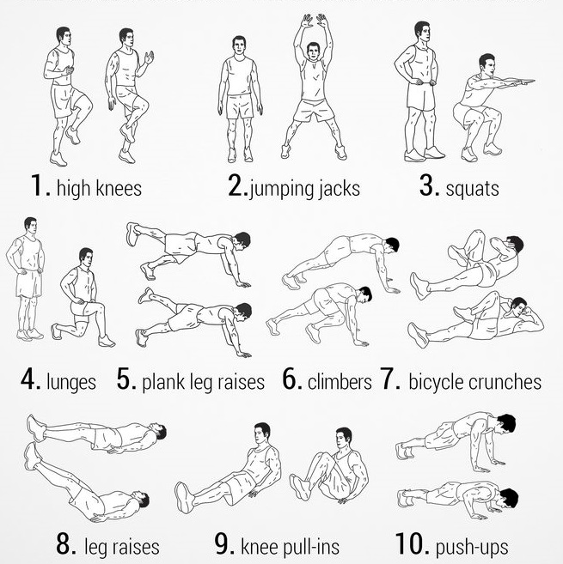

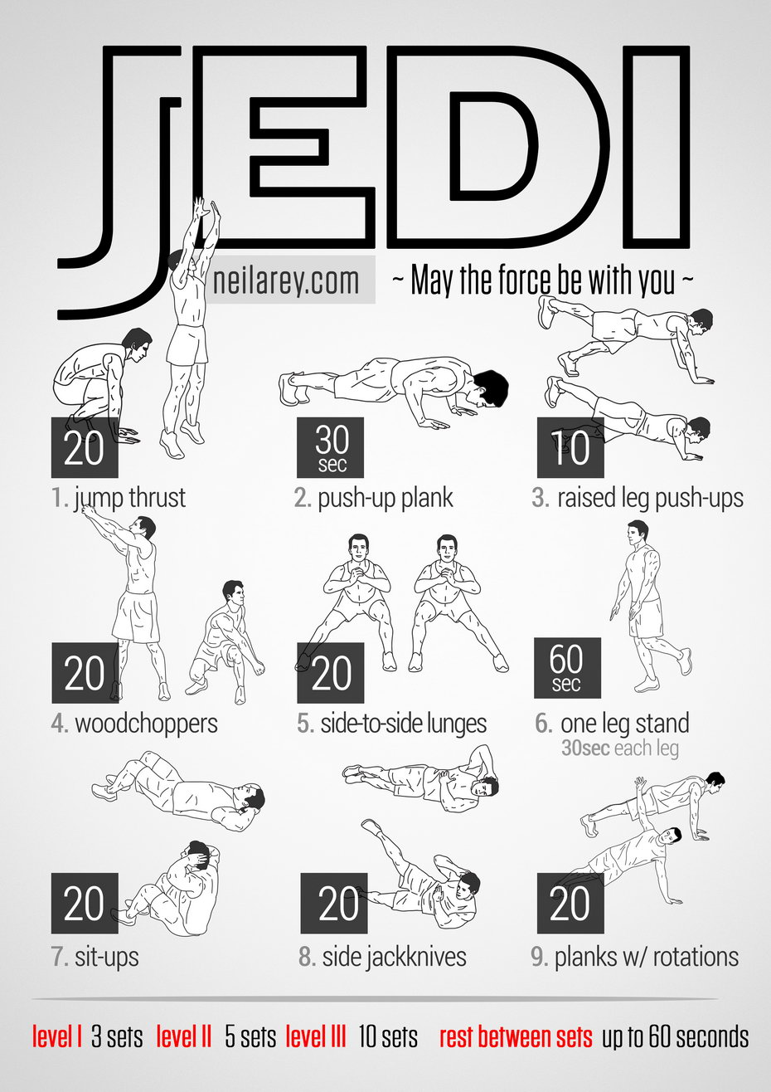
Superhero Workouts
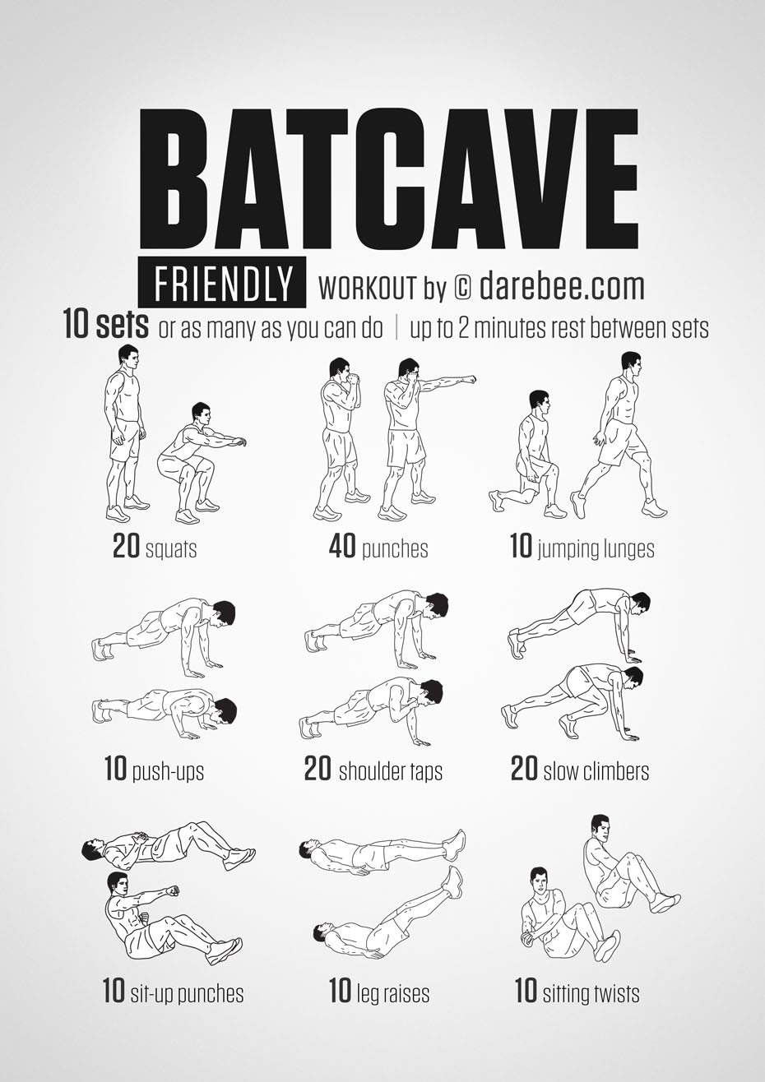
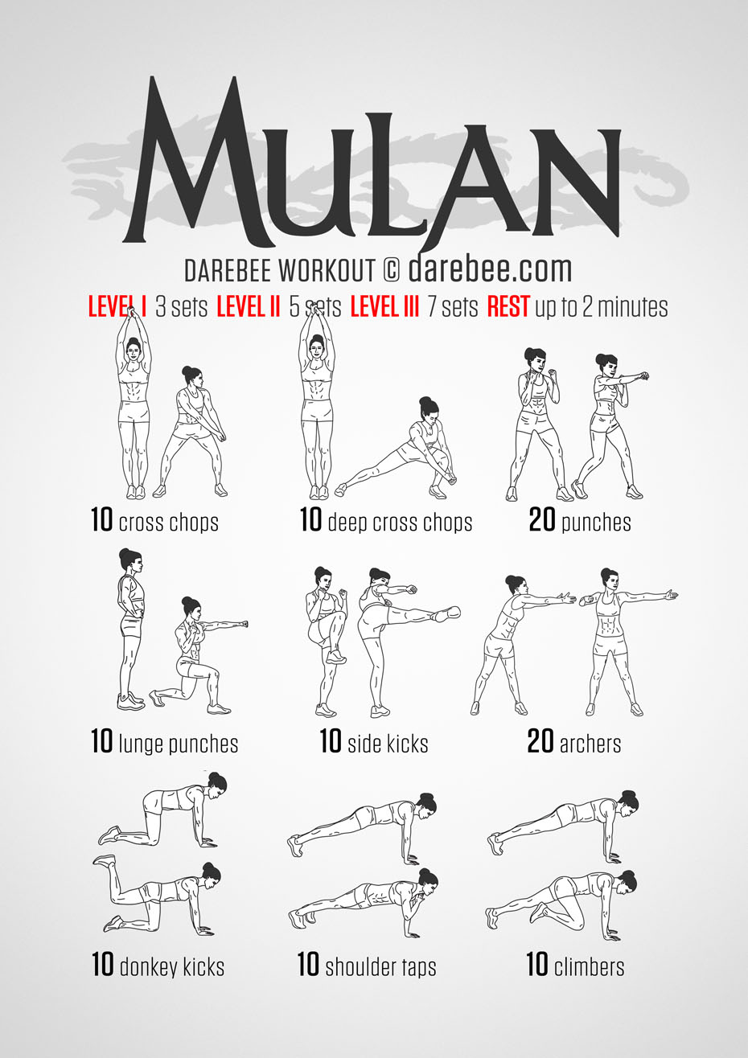
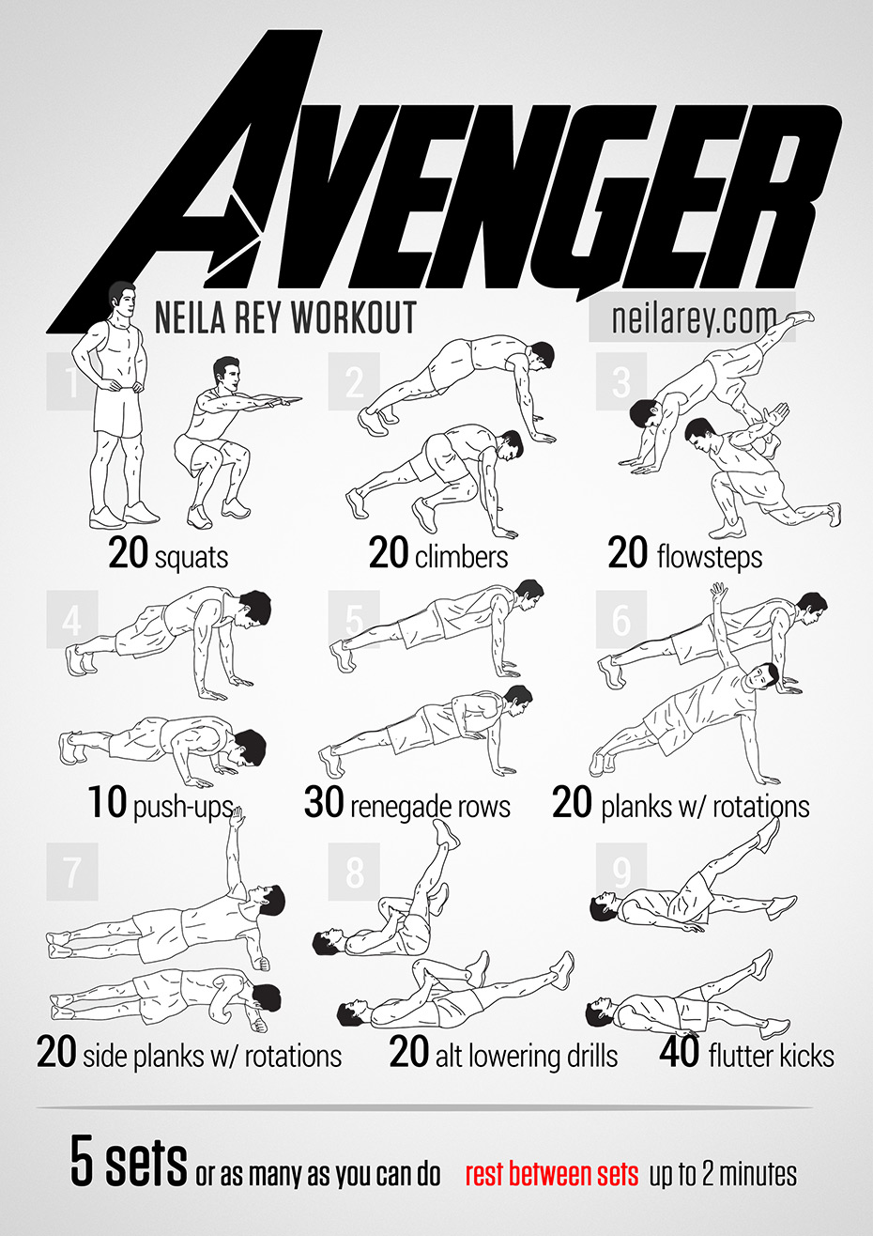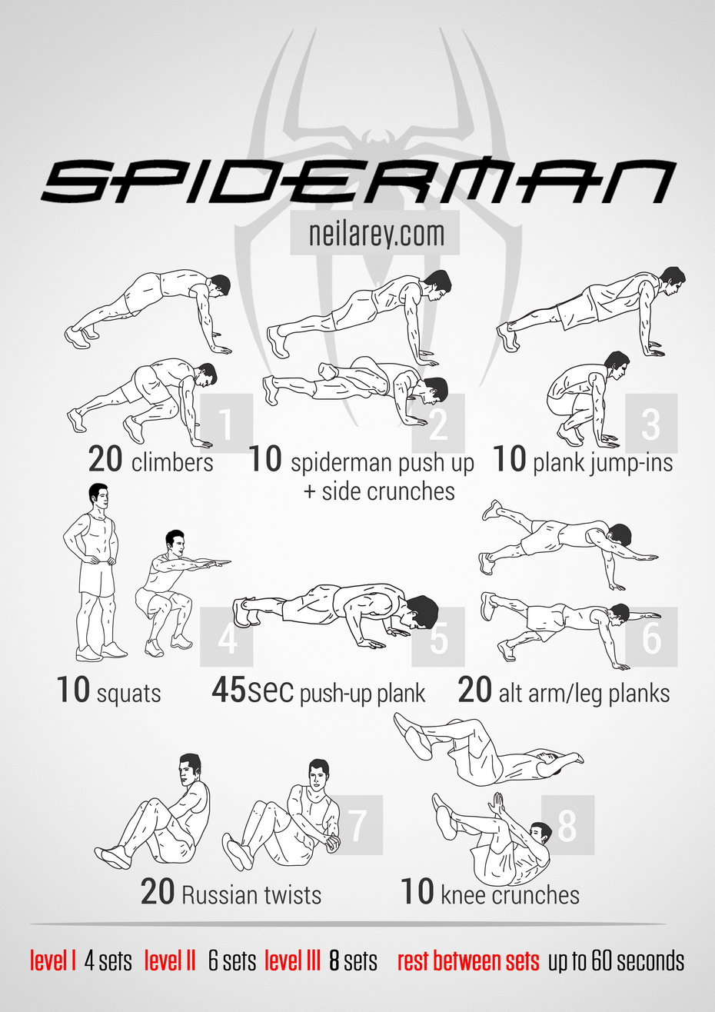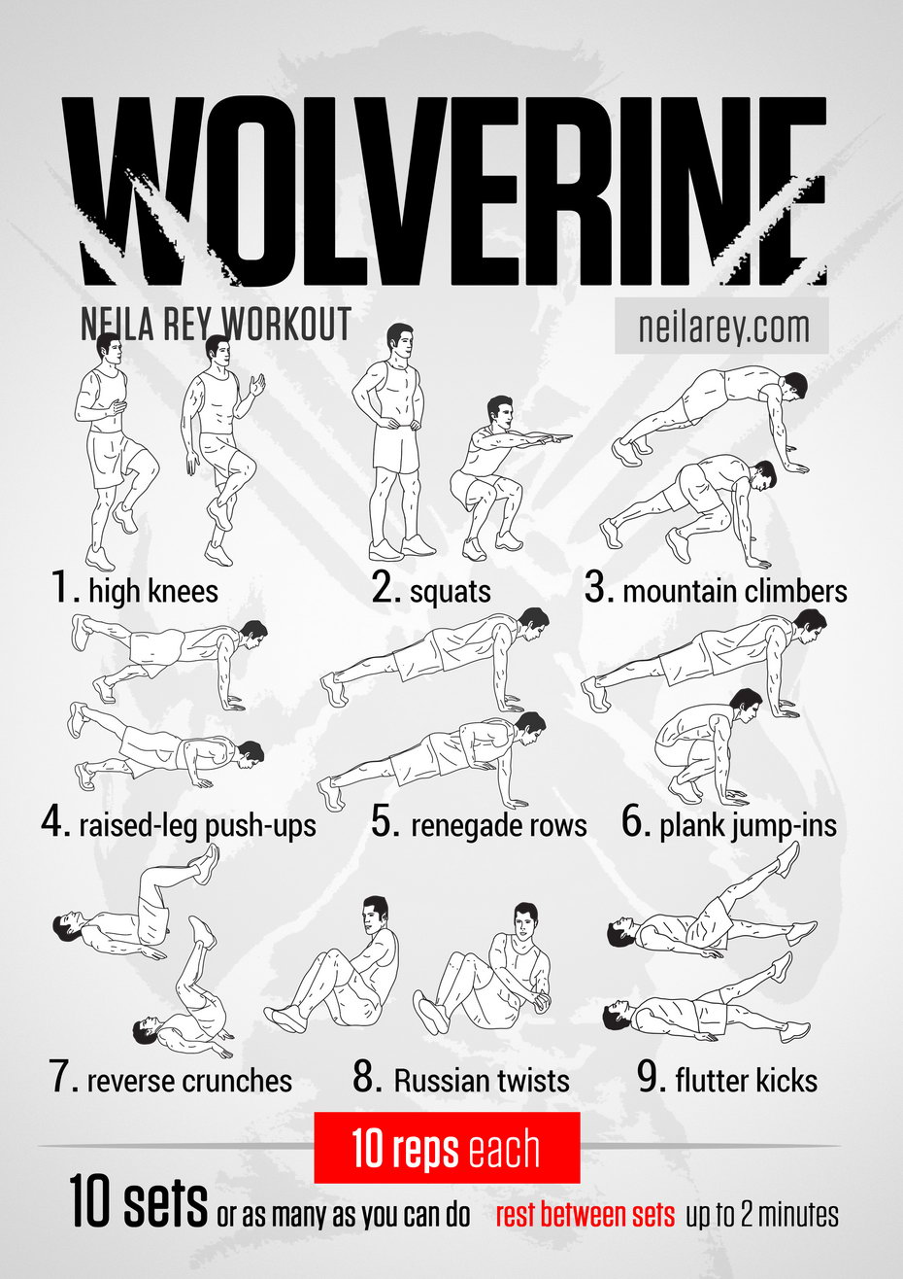

First female Little League player happy for 2 girls
By Associated Press
08.17.14

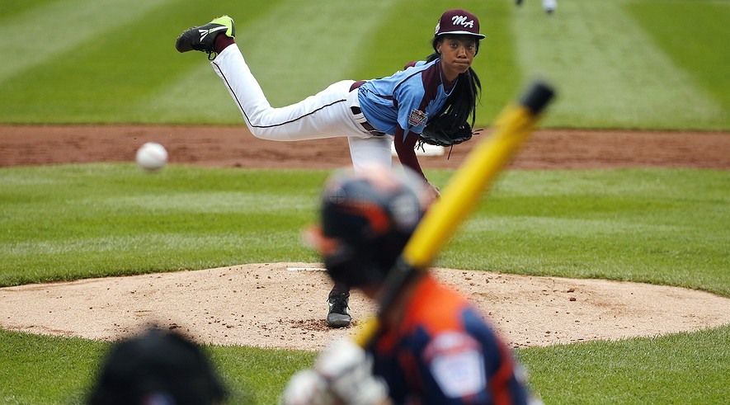Philadelphia's Mo'ne Davis delivers in the first inning against Nashville's Robert Hassell III during a baseball game in United States pool play at the Little League World Series tournament in South Williamsport, Pennsylvania, Friday, Aug. 15, 2014. Philadelphia won 4-0 with Davis pitching a two-hitter. AP Photo/Gene J. Puskar
SOUTH WILLIAMSPORT, Pa. — More than six decades after Kathryn "Tubby" Johnston Massar cut off her braids, tucked her hair under her cap and became the first girl to play Little League baseball, she's delighted to see two girls in the Little League World Series.
"It's truly amazing. I'm very happy to see girls playing," said Massar, 78, of Yuba City, California.
Philadelphia's Mo'ne Davis and Canada's Emma March became the 17th and 18th girls to play in the tournament Friday. It is only the third time in the event's 68-year history that two girls are playing in the same series.
Davis pitched a two-hitter to help Philadelphia beat Nashville 4-0. She had eight strikeouts and didn't walk a batter.
Davis, who received a noticeably louder reception than any other player during introductions, said she noticed plenty of girls younger than her in the audience. The applause heightened significantly when Davis struck out the final batter, becoming the first girl to throw a shutout in Little League World Series history.
"It's very unreal. I never thought at the age of 13 I would be a role model," Davis said. "Hopefully, more girls play Little League."
March did not fare as well.
Batting cleanup ahead of her brother, Evan, and playing first base, she went hitless Friday in Canada's 4-3 loss to Mexico.
But March created some excitement when she stepped into the batter's box for the Vancouver, British Columbia, team.
She drove a long fly ball to right field in the fourth inning that the crowd thought might be a home run. However, the hit sailed foul into the stands. Then in the top of the fifth, March stepped to the plate with the bases loaded and Canada down by two runs. After working the count to 2-2, she struck out looking on a pitch that caught the outside corner.
As March trotted back to the dugout, the crowd let the umpire know its opinion of the call as boos rained down from the stands.
Massar, slated to throw out the first pitch at one of Monday's games, believes more girls will start to play in Little League and beyond. She thinks eventually there will be a woman in Major League Baseball.
Massar played in 1950, leading to a rule barring girls from playing. That rule was overturned in 1974. The self-described "trailblazer" said she celebrates her role in history.
"It's something I'm proud of," she said. "Why not play baseball with the boys?"
Pennsylvania Gov. Tom Corbett was in South Williamsport on Friday and watched Davis' dominating performance.
"There's a lot of pressure on her, and she seems to be handling it very, very well for her age," Corbett said during the Philadelphia game, adding that the 13-year-old has a nice delivery. "It goes to show you how sports have moved the last 30 or 40 years, and we wouldn't have thought of this 40 or 50 years ago. And today, she's out there pitching, doing a great job and I'm sitting there thinking, 'Is she going to go into professional baseball?' I don't know.
"She's played as well as any kid out there right now."
Davis retired the first six batters and needed only 70 pitches. She was hitless in three at-bats.
Jared Sprague-Lott hit a three-run home run in the first inning, and Carter Davis had an RBI sacrifice fly in the sixth.
Also Friday in U.S. play, Pearland, Texas, beat Cumberland, Rhode Island, 6-4. In the other International game, Japan beat Venezuela 1-0.
The tournament opened with four games Thursday. In the U.S. bracket, Chicago beat Lynnwood, Washington, 12-2 in five innings, and Las Vegas topped Rapid City, South Dakota, 12-2, also in five innings. In the International games, Seoul, South Korea, beat Brno, Czech Republic, 10-3, and Humacao, Puerto Rico, topped Perth, Australia, 16-3 in four innings.

- A hyperbole is an extreme exaggeration used to make a point. It is like the opposite of “understatement.” It is from a Greek word meaning “excess.”
Examples:
- I am so hungry I could eat a horse.
- I have a million things to do.
- I had to walk 15 miles to school in the snow, uphill
- An idiom is a word or phrase that is not taken literally, like “bought the farm”
Examples:
Common idioms that refer to people include:
- A chip on your shoulder - means you are holding a grudge
- High as a kite - means you are drunk or on drugs
- Sick as a dog - means you are very ill

- The definition of a metaphor is "a figure of speech containing an implied comparison, in which a word or phrase ordinarily and primarily used of one thing is applied to another. For example, "the curtain of night" or "all the world's a stage."
Examples:
- He drowned in a sea of grief.
  - Sea of grief - How and where does one come across a sea that is filled not with water, but with grief?

- She is fishing in troubled waters.
  - Fishing - It is not used to mean that the person is actually fishing; it is an expression which is used to signify that the person is looking for something that is difficult to obtain.

- Personification is when you assign the qualities of a person to something that isn't human or, in some cases, to something that isn't even alive.
- Lightning danced across the sky.
- The wind howled in the night.
- The car complained as the key was turned.

Quiz
- In the section "No More 'No Girls Allowed'" select the paragraph that shows that baseball has changed in the last 50 years.

- Why did Little League Baseball institute a rule barring girls from playing in 1950?

- They were worried about the girl's safety.

- They did not think girls could compete with boys.

- The boys did not want to play baseball with girls.

- They thought boys were better than girls.

- Read the sentence: "As March trotted back to the dugout, the crowd let the umpire know it didn't agree with the call, as boos rained down from the stands. "What figure of speech was used?

- Alliteration

- Hyperbole

- metaphor

- personification

- Select the sentence that contains a word that is a synonym for "groundbreaker."
- She describes herself as a "trailblazer" and said she celebrates her role in history.

- But March created some excitement when she stepped into the batter's box for the Vancouver British Columbia team.

- She thinks eventually there will be a woman in Major League Baseball.

- The out made her the first girl to throw a shutout in Little League World Series history.

Cleveland homecomings: Not just LeBron
By Los Angeles Times, adapted by Newsela staff
07.23.14
Grade Level 6Word Count 843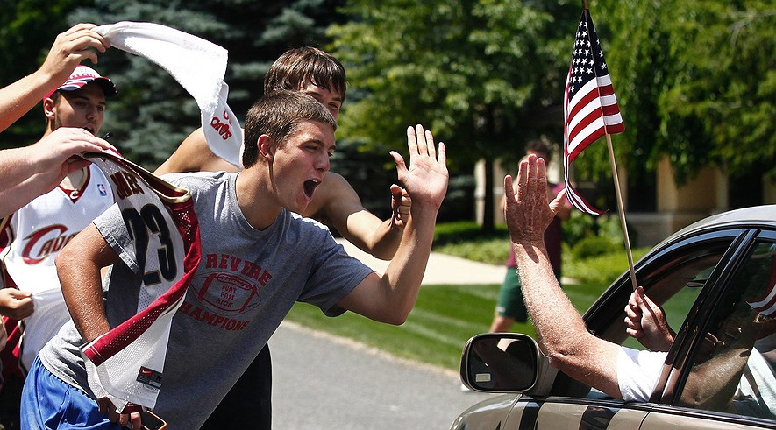Chance Costanzo (front) and Clay Erdie celebrate outside of LeBron James' home in Copley Township, Ohio, after hearing he is returning to play for the Cleveland Cavaliers on July 11, 2014. Karen Schiely/Akron Beacon Journal/MCT
CLEVELAND — Roz Quarto decided to pick up and move to Cleveland two years ago because she thought it seemed like a nice place.
She made her decision long before basketball star LeBron James decided to do the same. He announced last week that “bringing one trophy back to northeast Ohio” for the Cleveland Cavaliers is his new priority.
Friends in Quarto's hometown of New York City all reacted the same way.
“They said, ‘Cleveland, as in, Ohio?’” Quarto said while sitting on a bustling patio surrounded by blooming flower boxes in the city’s Ohio City neighborhood.
Now, she and her partner own a big yellow house not far from Ohio City. The neighborhood was recently named by USA Today as a top place for nightlife.
When friends from New York come to visit, Quarto says, they get it.
Her partner’s boss, who lives in Alaska, even purchased a second home in Cleveland.

Sports, Politics Lead The Way
Three things have put Cleveland in the spotlight in recent days. James decided to move back to his hometown Cavaliers. Then college quarterback Johnny Manziel signed with the NFL’s Cleveland Browns. Finally, the Republican Party picked the city for its 2016 national convention. The convention is a meeting of Republicans to nominate members of the party to run for president and vice president.
Locals say all of it is simply proof that Cleveland is coming back.
“The GOP and LeBron are going to grease the skids on a process that’s already started,” said Richey Piiparinen. He researches population changes at Cleveland State University. “People are realizing it’s not your grandpa’s Rust Belt anymore.” Piiparinen was using the term for the northeastern and central states that used to have a lot of factories.

Are Changes Helping Everyone?
Changes are already evident in the city.
New construction is booming. Hammers and drills sound at all hours on the Flats East Bank. The area used to be popular, but fell into disarray a decade ago. Now it is coming back.
Downtown, a new convention center just opened. Developers also are rushing to build hotels and luxury condos to keep up with demand. Ohio’s first casino opened downtown in 2012. Meanwhile, restaurants are opening where you can get entrees such as frog legs and rabbit pie.
To be sure, Cleveland still has its problems. There is a lot of poverty. Half of the city’s children lived in poverty in 2012, a rate second only to that of Detroit, according to the National Center for Children in Poverty. The years of people leaving the city have also led to neighborhoods of vacant homes.
“It’s still same old, same old here,” said Vickie Williams. She works downtown and has seen the changes there, but says that no boom has trickled into her neighborhood. People there still beg for money outside the Dollar General and tall weeds grow in empty lots where houses once stood.

Homecomings All Around
Still, Cuyahoga County saw more people move from Brooklyn and Chicago between 2007 and 2011 than it sent to those places, Piiparinen said. Although the Cleveland area lost population between 2006 and 2012, it added 40,000 people with college degrees during that period. Also, the number of educated 25- to 34-year-olds grew 68 percent, according to Piiparinen’s research.
Many young people fled Cleveland and other Rust Belt cities in the 2000s for places such as Chicago, San Francisco and New York, Piiparinen said. But as those cities became more crowded, costs began rising and many people were priced out. Now, he said, people are moving home. They are coming back not just to Cleveland, but to Pittsburgh, St. Louis and Buffalo, New York, as well.
“It’s what we call ‘big fish, small pond’ talent migration. Are you going to get lost in the shuffle of New York City, or are you going to come back and make a huge difference in your community?” Piiparinen said.

Stop In, Look Around, Stay
Roz Quarto was motivated to move to Cleveland in part by the high cost of living in the New York metro area. She feared she and her partner would never earn enough money there.
On a road trip from Alaska to New York, Quarto and her partner, Gail L. Palmer, stopped in Cleveland and intended to stay three days. They stayed for 10. It wasn’t long before they decided to try living here.
“We figured we’d see if we liked it, and sign a year lease,” Quarto said. “Then we fell deeper and deeper in love with the city.”
In late 2010, developers announced that the Flats East Bank project received the funding to begin building. In January 2011, the city broke ground on a $465 million medical mart and convention center.
Something about Cleveland was beginning to lure back young people. Like LeBron, they just needed some time elsewhere before they returned.
“The first inclination that college-age kids in Cleveland used to have was to flee,” said Adam Fishman. He works at Fairmount Properties, which is developing the Flats. “Somehow that has now changed.”

Quiz
    - Select the paragraph from "Homecomings All Around" that draws a comparison between the number of people migrating in and out of Cleveland.

2. The article draws a connection between Cleveland and all of the following EXCEPT:
a. the Flats East Bank project

    - high cost of living

c LeBron James

- Brooklyn

3. Select the sentence that contains a word that is a synonym for "choose."

- "They said, 'Cleveland, as in, Ohio?'" Quarto said while sitting on a bustling patio surrounded by blooming flower boxes in the city's Ohio City neighborhood.

- The convention is a meeting of Republicans to nominate members of the party to run for president and vice presiden

- Developers also are rushing to build hotels and luxury condos to keep up with demand.

- She works downtown and has seen the changes there, but says that no boom has trickled into her neighborhood.

4.Select the sentence that contains a word that is an antonym for "arrive."

- Developers also are rushing to build hotels and luxury condos to keep up with demand.

- They are coming back not just to Cleveland, but to Pittsburgh, St. Louis and Buffalo, New York, as well.

- Many young people fled Cleveland and other Rust Belt cities in the 2000s for places such as Chicago, San Francisco and New York, Piiparinen said

- Something about Cleveland was beginning to lure back young people.

